STA302A2

## ISHAAN NAGI

## 1002452525

SETUP

setwd("~/Google Drive/Uni/Winter 2018/STA302/A2")  
dat <- read.table("Census.txt", sep = "" ,header=T)  
LIFE <- dat$LIFE  
MALE <- dat$MALE  
BIRTH <- dat$BIRTH  
DIVO <- dat$DIVO  
BEDS <- dat$BEDS  
EDUC <- dat$EDUC  
INCO <- dat$INCO  
y <- LIFE

x = as.matrix(dat)  
x <-x[1:51, 2:7]  
x<- cbind(1, x)  
mode(x) = 'numeric'  
n <- 51  
p <-6  
X<-x  
Xt <- t(X)  
XtX <- Xt %*% X  
XtXinv <-solve(XtX)  
Xty <- Xt %*% y  
bhat <- XtXinv %*% Xty

1a)

y_hat <- X %*% bhat  
y_hat

## [,1]  
## [1,] 71.32712  
## [2,] 69.44152  
## [3,] 70.61014  
## [4,] 70.29776  
## [5,] 71.65898  
## [6,] 71.97295  
## [7,] 72.28677  
## [8,] 66.87019  
## [9,] 70.41924  
## [10,] 71.38047  
## [11,] 69.42376  
## [12,] 71.53120  
## [13,] 71.42614  
## [14,] 71.04053  
## [15,] 70.16589  
## [16,] 70.29139  
## [17,] 71.64995  
## [18,] 70.78642  
## [19,] 70.31884  
## [20,] 70.92242  
## [21,] 72.03916  
## [22,] 70.25335  
## [23,] 70.24288  
## [24,] 71.16816  
## [25,] 70.77073  
## [26,] 68.72947  
## [27,] 72.04422  
## [28,] 70.81770  
## [29,] 71.67050  
## [30,] 71.22929  
## [31,] 71.04496  
## [32,] 72.13043  
## [33,] 70.80619  
## [34,] 68.76111  
## [35,] 70.46957  
## [36,] 70.31486  
## [37,] 71.13894  
## [38,] 72.51628  
## [39,] 70.91515  
## [40,] 71.43818  
## [41,] 70.51633  
## [42,] 71.11649  
## [43,] 70.03452  
## [44,] 70.18014  
## [45,] 69.57848  
## [46,] 71.56217  
## [47,] 70.51127  
## [48,] 72.50224  
## [49,] 71.48537  
## [50,] 69.92352  
## [51,] 70.45665

e_hat = y - y_hat  
e_hat

## [,1]  
## [1,] -2.01712273  
## [2,] -0.39152270  
## [3,] 0.04985782  
## [4,] 0.25224335  
## [5,] 0.05102320  
## [6,] 0.08704553  
## [7,] 0.19323411  
## [8,] -1.16019333  
## [9,] -0.35923989  
## [10,] -0.72046876  
## [11,] -0.88376476  
## [12,] 2.06880340  
## [13,] 1.13386172  
## [14,] 0.82946681  
## [15,] -0.02589499  
## [16,] 0.58861254  
## [17,] 0.93004669  
## [18,] -0.68642174  
## [19,] -1.55884433  
## [20,] 0.90758262  
## [21,] -1.81915643  
## [22,] 0.67665009  
## [23,] 0.38711962  
## [24,] 1.79184021  
## [25,] -0.08073436  
## [26,] -0.63947073  
## [27,] -1.48421996  
## [28,] -1.60770155  
## [29,] 1.11949999  
## [30,] 1.37071164  
## [31,] 0.18503566  
## [32,] -1.20043418  
## [33,] -0.48618775  
## [34,] 0.26888640  
## [35,] 0.08043332  
## [36,] 0.50514224  
## [37,] 0.28105954  
## [38,] -0.38627710  
## [39,] -0.48514830  
## [40,] 0.46181996  
## [41,] -2.55632758  
## [42,] 0.96350641  
## [43,] 0.07548104  
## [44,] 0.71986346  
## [45,] 3.32151698  
## [46,] -1.48217033  
## [47,] 1.12872551  
## [48,] -0.78223737  
## [49,] 0.99463448  
## [50,] -0.44351769  
## [51,] -0.16664779

bhat

## [,1]  
## 70.5577812705  
## MALE 0.1261018758  
## BIRTH -0.5160557876  
## DIVO -0.1965375074  
## BEDS -0.0033392036  
## EDUC 0.2368222541  
## INCO -0.0003612011

Equation: LIFE = 70.5577812705 + 0.1261018758 (MALE) - 0.5160557876 (BIRTH) - 0.1965375074 (DIVO) - 0.0033392036 (BEDS) + 0.2368222541 (EDUC) - 0.0003612011 (INCO)

1b) - MALE

bhat[2] #b_1

## [1] 0.1261019

b_1 (MALE) corresponds to the Expected change (+ 0.1261019) in the Averafe Lifespan with 1 unit increase in the proportion of Males to Female.

* BIRTH

bhat[3] #b_2

## [1] -0.5160558

b_2 (BIRTH) corresponds to the Expected change (-0.5160558) in the Averafe Lifespan with a unit increase in the birth rate per 1,000 people.

1c)

RSS <- (t(e_hat) %*% e_hat)  
sigma_sq_hat = RSS / (n)  
sigma_sq_hat

## [,1]  
## [1,] 1.192215

s_sq = RSS / (n-p-1)  
s_sq

## [,1]  
## [1,] 1.381885

1d)

s <-c(s_sq^(1/2))  
se_bs = diag(s * (XtXinv)^(1/2))  
se_bs

## MALE BIRTH DIVO BEDS   
## 4.2897471299 0.0472317551 0.1172774621 0.0739532971 0.0009795303   
## EDUC INCO   
## 0.1110224835 0.0004597943

#Corresponding to B_0, B_1 ... B_6

1e)

y_bar = c(sum(y_hat)/ n)  
SST <- sum((LIFE - y_bar)^(2))  
R_sq <- 1 - (RSS/SST)  
R_sq

## [,1]  
## [1,] 0.4684927

Explains the proportion of variation in the Average lifespan explained by the regression, which is 46.849%.

1. 2a)

MLR <- lm(formula = LIFE~ MALE + BIRTH + DIVO + BEDS + EDUC + INCO, data=dat)   
summary(MLR)

##   
## Call:  
## lm(formula = LIFE ~ MALE + BIRTH + DIVO + BEDS + EDUC + INCO,   
## data = dat)  
##   
## Residuals:  
## Min 1Q Median 3Q Max   
## -2.5563 -0.6629 0.0755 0.6983 3.3215   
##   
## Coefficients:  
## Estimate Std. Error t value Pr(>|t|)   
## (Intercept) 70.5577813 4.2897471 16.448 < 2e-16 ***  
## MALE 0.1261019 0.0472318 2.670 0.01059 *   
## BIRTH -0.5160558 0.1172775 -4.400 6.78e-05 ***  
## DIVO -0.1965375 0.0739533 -2.658 0.01093 *   
## BEDS -0.0033392 0.0009795 -3.409 0.00141 **   
## EDUC 0.2368223 0.1110225 2.133 0.03853 *   
## INCO -0.0003612 0.0004598 -0.786 0.43633   
## ---  
## Signif. codes: 0 '***' 0.001 '**' 0.01 '*' 0.05 '.' 0.1 ' ' 1  
##   
## Residual standard error: 1.176 on 44 degrees of freedom  
## Multiple R-squared: 0.4685, Adjusted R-squared: 0.396   
## F-statistic: 6.464 on 6 and 44 DF, p-value: 6.112e-05

2b) $H_{0}:B_{0}=B_{1}=B_{2}=B_{3}=B_{4}=B_{5}=B_{6}=0$ $H_{A}:B_{i}≠0$ [any i in range 0 to 6]

SSReg = SST-RSS  
F_val = (SSReg/(p)/(RSS/(n-p-1)))   
F_val

## [,1]  
## [1,] 6.463905

F_crt = qf(.95, df1=p, df2=n-p-1)  
F_crt

## [1] 2.313264

F_val > F_crit, hence we fail to accept $H_{0}$. Then atleast one of the B_i’s [i = 1, … 6] is not Zero. Our Model is significant.

2c)

# MALE

$H_{0}:B_{1}=0$ $H_{A}:B_{1}≠0$

t_value1 =2.670  
t_crit = qt(c(.005, .995), df=n-p-1)  
#t_crit = [-2.692278, 2.692278]

Since |t_crit| > |t_value1|, we accept $H_{0}$. Then $B_{1}≠0$ and we can remove the predictor (MALE) from the model.

# BIRTH

$H_{0}:B_{2}=0$ $H_{A}:B_{2}!=0$

t_value2 = 4.400  
t_crit = qt(c(.005, .995), df=n-p-1)  
#t_crit = [-2.692278, 2.692278]

Since |t_value2| > |t_crit|, we fail to accept $H_{0}$. Then $B_{2}≠0$ then we can’t remove the predictor (BIRTH) variable from the model.

# 

# DIVO

$H_{0}:B_{3}=0$ $H_{A}:B_{3}≠0$

t_value3 =2.658  
t_crit = qt(c(.005, .995), df=n-p-1)  
#t_crit = [-2.692278, 2.692278]

Since |t_crit| > |t_value3|, we accept $H_{0}$. Then $B_{3}≠0$ and we can remove the predictor (DIVO) from the model.

# BEDS

$H_{0}:B4=0$ $H_{A}:B4≠0$

t_value4 =3.409  
t_crit = qt(c(.005, .995), df=n-p-1)  
#t_crit = [-2.692278, 2.692278]

Since |t_value4| > |t_crit|, we fail to accept $H_{0}$. Then $B_{4}≠0$ then we can’t remove the predictor (BEDS) variable from the model.

# EDUC

$H_{0}:B5=0$ $H_{A}:B5≠0$

t_value5 = 2.133  
t_crit = qt(c(.005, .995), df=n-p-1)  
#t_crit = [-2.692278, 2.692278]

Since |t_crit| > |t_value5|, we accept $H_{0}$. Then $B_{3}≠0$ and we can remove the predictor (EDUC) from the model.

# INCO

$H_{0}:B6=0$ $H_{A}:B6≠0$

t_value6 =0.786  
t_crit = qt(c(.005, .995), df=n-p-1)  
#t_crit = [-2.692278, 2.692278]

Since |t_crit| > |t_value6|, we accept $H_{0}$. Then $B_{6}≠0$ and we can remove the predictor (INCO) from the model.

Yes, the results indicate that variables MALE (x1), DIVO (x3), EDUC (x5) and INCO x(6) should be removed.

2d)

MLR_reduced <- lm(formula = LIFE~ BIRTH + BEDS, data=dat)   
summary(MLR_reduced)

##   
## Call:  
## lm(formula = LIFE ~ BIRTH + BEDS, data = dat)  
##   
## Residuals:  
## Min 1Q Median 3Q Max   
## -2.5627 -0.8180 -0.0819 0.9261 3.6202   
##   
## Coefficients:  
## Estimate Std. Error t value Pr(>|t|)   
## (Intercept) 79.1473186 2.2717401 34.840 < 2e-16 ***  
## BIRTH -0.3281679 0.1026214 -3.198 0.00245 **   
## BEDS -0.0027415 0.0009388 -2.920 0.00531 **   
## ---  
## Signif. codes: 0 '***' 0.001 '**' 0.01 '*' 0.05 '.' 0.1 ' ' 1  
##   
## Residual standard error: 1.352 on 48 degrees of freedom  
## Multiple R-squared: 0.2329, Adjusted R-squared: 0.2009   
## F-statistic: 7.286 on 2 and 48 DF, p-value: 0.001725

LIFE = 79.1473186 - 0.3281679 (BIRTH) - 0.0027415 (BEDS)

2e) $H_{0}:B_{1}=B_{6}=0$ $H_{A}:B_{1},B_{6}$ both not zero.

MLR_red_MALE_INCO <- lm(formula = LIFE~ BIRTH + BEDS + DIVO + EDUC, data=dat)   
anova(MLR, MLR_red_MALE_INCO)

## Analysis of Variance Table  
##   
## Model 1: LIFE ~ MALE + BIRTH + DIVO + BEDS + EDUC + INCO  
## Model 2: LIFE ~ BIRTH + BEDS + DIVO + EDUC  
## Res.Df RSS Df Sum of Sq F Pr(>F)   
## 1 44 60.803   
## 2 46 70.654 -2 -9.8507 3.5642 0.03676 *  
## ---  
## Signif. codes: 0 '***' 0.001 '**' 0.01 '*' 0.05 '.' 0.1 ' ' 1

F_val = 3.5642  
F_Crit = qf(.99, df1=2, df2=n-p-1)  
#F_Crit = 5.122628

|F_val| > |F_crit| we fail to reject $H_{0}$, hence the predictors MALE and INCO can be removed from the model.

2f)

MLR_MALE <- lm(LIFE ~ MALE, data=dat)   
anova(MLR, MLR_MALE)

## Analysis of Variance Table  
##   
## Model 1: LIFE ~ MALE + BIRTH + DIVO + BEDS + EDUC + INCO  
## Model 2: LIFE ~ MALE  
## Res.Df RSS Df Sum of Sq F Pr(>F)   
## 1 44 60.803   
## 2 49 109.834 -5 -49.031 7.0963 6.099e-05 ***  
## ---  
## Signif. codes: 0 '***' 0.001 '**' 0.01 '*' 0.05 '.' 0.1 ' ' 1

F_val = 7.0963

We fail to accept $H_{0}$, hence we infer that predictors BIRTH (x2), DIVO (x3), BEDS (x4), EDUC (x5) and INCO (x6) are significant after taking the predictor MALE (x1) into consideration.

2g) $H_{0}:B_{i}=0$ [i = 1, 2] $H_{A}:$ $B_{1},B_{2}$, both not zero.

MLR_B0 = lm(LIFE ~ 1, data=dat)   
MLR_MALE_BIRTH <- lm(LIFE ~ MALE + BIRTH, data=dat)   
anova(MLR_B0, MLR_MALE_BIRTH)

## Analysis of Variance Table  
##   
## Model 1: LIFE ~ 1  
## Model 2: LIFE ~ MALE + BIRTH  
## Res.Df RSS Df Sum of Sq F Pr(>F)   
## 1 50 114.397   
## 2 48 85.424 2 28.973 8.14 0.0009036 ***  
## ---  
## Signif. codes: 0 '***' 0.001 '**' 0.01 '*' 0.05 '.' 0.1 ' ' 1

F_val = 8.14

We fail to accept the $H_{0}$, we infer that (MALE) x1 and(BIRTH) x2 are significant/useful in predicting the response.

2h)

MLR_B0 = lm(LIFE ~ 1, data=dat)   
MLR_B0B3 = lm(LIFE ~ DIVO)  
MLR_B0B2B3 = lm(LIFE ~ BIRTH + DIVO)  
MLR_MALE_BIRTH_DIVO <- lm(LIFE~ MALE + BIRTH + DIVO, data=dat)   
MLR_BIRTH_DIVO <- lm(LIFE ~ BIRTH + DIVO, data=dat)

SSRegB3B0 <- anova(MLR_B0)["Residuals", "Sum Sq"] - anova(MLR_B0B3)["Residuals", "Sum Sq"]  
SSRegB3B0

## [1] 3.307311

SSRegB2_B0B3 <- anova(MLR_B0B3)["Residuals", "Sum Sq"] - anova(MLR_B0B2B3)["Residuals", "Sum Sq"]  
SSRegB2_B0B3

## [1] 8.914548

RSSB0B1B2B3 <- anova(MLR_MALE_BIRTH_DIVO)["Residuals", "Sum Sq"]  
  
RSS_B0B2B3 <- anova(MLR_BIRTH_DIVO)["Residuals", "Sum Sq"]   
  
SSRegB1_B0B2B3 <- RSS_B0B2B3 - RSSB0B1B2B3  
SSRegB1_B0B2B3

## [1] 21.42422

SSRegB1B2B3_B0 = SSRegB3B0 + SSRegB2_B0B3 + SSRegB1_B0B2B3  
SSRegB1B2B3_B0

## [1] 33.64607

2i)

- 1

#MLR_B0  
#MLR_MALE  
MLR_BIRTH <- lm(LIFE ~ BIRTH, data=dat)   
MLR_DIVO <- lm(LIFE ~ DIVO, data=dat)   
MLR_INCO <- lm(LIFE ~ INCO, data=dat)   
#MLR_MALE_BIRTH  
MLR_MALE_DIVO <- lm(LIFE~ MALE + DIVO, data=dat)   
MLR_MALE_INCO <- lm(LIFE~ MALE + INCO, data=dat)   
#MLR_BIRTH_DIVO  
MLR_BIRTH_INCO <- lm(LIFE ~ BIRTH + INCO, data=dat)   
MLR_DIVO_INCO <- lm(LIFE ~ DIVO + INCO, data=dat)   
MLR_MALE_BIRTH_DIVO

##   
## Call:  
## lm(formula = LIFE ~ MALE + BIRTH + DIVO, data = dat)  
##   
## Coefficients:  
## (Intercept) MALE BIRTH DIVO   
## 62.3656 0.1689 -0.3912 -0.1272

MLR_MALE_BIRTH_INCO <- lm(LIFE~ MALE + BIRTH + INCO, data=dat)   
MLR_BIRTH_DIVO_INCO <- lm(LIFE ~ BIRTH + DIVO + INCO, data=dat)   
MLR_MALE_DIVO_INCO <- lm(LIFE ~ MALE + DIVO + INCO, data=dat)   
MLR_mbdi <- lm(LIFE ~ MALE + BIRTH + DIVO + INCO, data=dat)   
  
#AIC  
aic_b0 <- AIC(MLR_B0)   
aic_b0

## [1] 189.9321

aic_m <- AIC(MLR_MALE)   
aic_m

## [1] 189.8561

aic_d <- AIC(MLR_DIVO)  
aic_d

## [1] 190.4359

aic_i <- AIC(MLR_INCO)  
aic_i

## [1] 191.2477

aic_b <- AIC(MLR_BIRTH)  
aic_b

## [1] 186.7525

aic_mb <- AIC(MLR_MALE_BIRTH)  
aic_mb

## [1] 179.0377

aic_md <- AIC(MLR_MALE_DIVO)  
aic_md

## [1] 188.5535

aic_mi <- AIC(MLR_MALE_INCO)  
aic_mi

## [1] 191.4429

aic_bd <- AIC(MLR_BIRTH_DIVO)  
aic_bd

## [1] 188.1698

aic_bi <- AIC(MLR_BIRTH_INCO)  
aic_bi

## [1] 188.5226

aic_di <- AIC(MLR_DIVO_INCO)  
aic_di

## [1] 191.4755

aic_mbd <- AIC(MLR_MALE_BIRTH_DIVO)  
aic_mbd

## [1] 178.1686

aic_mbi <- AIC(MLR_MALE_BIRTH_INCO)  
aic_mbi

## [1] 180.932

aic_bdi <- AIC(MLR_BIRTH_DIVO_INCO)  
aic_bdi

## [1] 189.8012

aic_mdi <- AIC(MLR_MALE_DIVO_INCO)  
aic_mdi

## [1] 189.9273

aic_mbdi <- AIC(MLR_mbdi)  
aic_mbdi

## [1] 180.1406

Lowest AIC is with model LIFE ~ BIRTH + MALE + DIVO

- 2

null<- MLR_B0  
full<- MLR_mbdi  
forwdAIC=step(null, scope=list(lower=null, upper=full), direction="forward")

## Start: AIC=43.2  
## LIFE ~ 1  
##   
## Df Sum of Sq RSS AIC  
## + BIRTH 1 11.0479 103.35 40.021  
## + MALE 1 4.5632 109.83 43.124  
## <none> 114.40 43.200  
## + DIVO 1 3.3073 111.09 43.704  
## + INCO 1 1.5249 112.87 44.516  
##   
## Step: AIC=40.02  
## LIFE ~ BIRTH  
##   
## Df Sum of Sq RSS AIC  
## + MALE 1 17.9252 85.424 32.306  
## <none> 103.349 40.021  
## + DIVO 1 1.1739 102.175 41.438  
## + INCO 1 0.4647 102.885 41.791  
##   
## Step: AIC=32.31  
## LIFE ~ BIRTH + MALE  
##   
## Df Sum of Sq RSS AIC  
## + DIVO 1 4.6730 80.751 31.437  
## <none> 85.424 32.306  
## + INCO 1 0.1768 85.247 34.200  
##   
## Step: AIC=31.44  
## LIFE ~ BIRTH + MALE + DIVO  
##   
## Df Sum of Sq RSS AIC  
## <none> 80.751 31.437  
## + INCO 1 0.044334 80.707 33.409

Best Model according to forwardAIC is LIFE ~ BIRTH + MALE + DIVO

- 3

backAIC=step(full, direction="backward", data=dat)

## Start: AIC=33.41  
## LIFE ~ MALE + BIRTH + DIVO + INCO  
##   
## Df Sum of Sq RSS AIC  
## - INCO 1 0.0443 80.751 31.437  
## <none> 80.707 33.409  
## - DIVO 1 4.5405 85.247 34.200  
## - MALE 1 20.7328 101.440 43.070  
## - BIRTH 1 20.9838 101.691 43.196  
##   
## Step: AIC=31.44  
## LIFE ~ MALE + BIRTH + DIVO  
##   
## Df Sum of Sq RSS AIC  
## <none> 80.751 31.437  
## - DIVO 1 4.673 85.424 32.306  
## - MALE 1 21.424 102.175 41.438  
## - BIRTH 1 22.196 102.947 41.822

Best Model according to backwardAIC is LIFE ~ BIRTH + MALE + DIVO

3a)

std_res <- rstandard(MLR)  
plot(MLR$fitted.values, std_res, ylab="Standardized Residuals", xlab="Fitted Values", main="Standardized Residuals")  
abline(0, 0)  
abline(2, 0, col=c("red"))  
abline(-2, 0, col=c("red"))

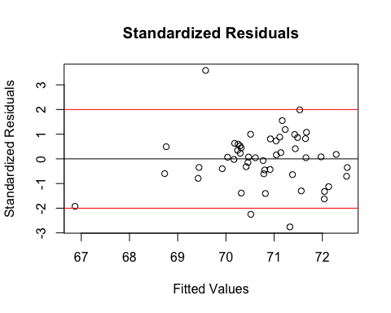

Yes, there are 3 points with residuals greater than |2| and an outlier that may be influential with the lowest fitted value (~67).

3b)

lev = hat(model.matrix(MLR))  
plot(lev)  
abline(0.5, 0, col=c("red"))

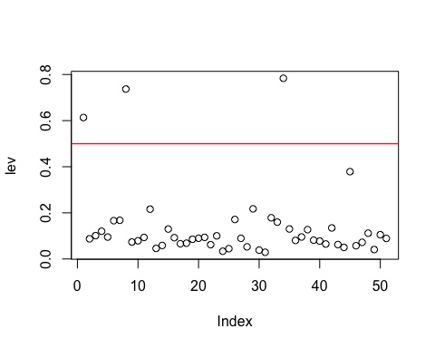

dat[lev >0.5,]

## STATE MALE BIRTH DIVO BEDS EDUC INCO LIFE  
## 1 AK 119.1 24.8 5.6 603.3 14.1 4638 69.31  
## 8 DC 86.8 20.1 3.0 1859.4 17.8 4644 65.71  
## 34 NV 102.8 19.6 18.7 560.7 10.8 4583 69.03

3 points have lev > 0.5. Indices 1, 8 and 34. Corresponding to States: AK, DC and NV.

3c)

cook = cooks.distance(MLR)  
plot(cook)

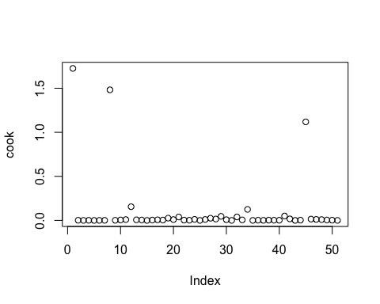

dat[cook > 1,]

## STATE MALE BIRTH DIVO BEDS EDUC INCO LIFE  
## 1 AK 119.1 24.8 5.6 603.3 14.1 4638 69.31  
## 8 DC 86.8 20.1 3.0 1859.4 17.8 4644 65.71  
## 45 UT 97.6 25.5 3.7 470.5 14.0 3169 72.90

No, not all Observations are the same. We now see data corresponding to UT instead of NV.

3d)

plot(BEDS, std_res, ylab="Standardized Residuals",   
 xlab="BEDS", main="Standardized Residuals")  
abline(0, 0)  
abline(2, 0, col=c("red"))  
abline(-2, 0, col=c("red"))  
points(BEDS[8], std_res[8] , col='red', pch = 19)

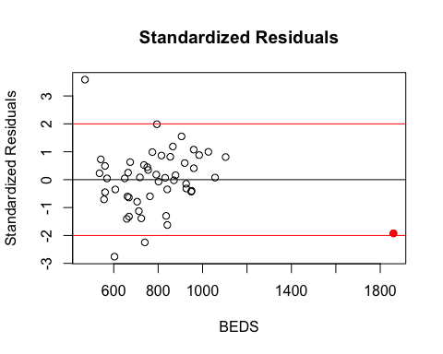

There are 3 points that are outliers based on std_res (>2) and the outlier red point corresponding to DC (RED)

3e)

dat2 <- subset(dat, STATE != 'DC')  
LIFE2 <- dat2$LIFE  
MALE2 <- dat2$MALE  
BIRTH2 <- dat2$BIRTH  
DIVO2 <- dat2$DIVO  
BEDS2 <- dat2$BEDS  
EDUC2 <- dat2$EDUC  
INCO2 <- dat2$INCO  
MLR_NoDC <- lm(formula = LIFE2 ~ MALE2 + BIRTH2 + DIVO2 + BEDS2 + EDUC2 + INCO2, data=dat2)  
summary(MLR_NoDC)

##   
## Call:  
## lm(formula = LIFE2 ~ MALE2 + BIRTH2 + DIVO2 + BEDS2 + EDUC2 +   
## INCO2, data = dat2)  
##   
## Residuals:  
## Min 1Q Median 3Q Max   
## -2.48448 -0.61603 -0.00768 0.58701 3.07199   
##   
## Coefficients:  
## Estimate Std. Error t value Pr(>|t|)   
## (Intercept) 69.8207566 4.1692564 16.747 < 2e-16 ***  
## MALE2 0.0922054 0.0487996 1.889 0.06558 .   
## BIRTH2 -0.4261398 0.1222113 -3.487 0.00114 **   
## DIVO2 -0.1377833 0.0774530 -1.779 0.08232 .   
## BEDS2 -0.0011637 0.0014481 -0.804 0.42604   
## EDUC2 0.3157699 0.1145801 2.756 0.00855 **   
## INCO2 -0.0004698 0.0004485 -1.048 0.30064   
## ---  
## Signif. codes: 0 '***' 0.001 '**' 0.01 '*' 0.05 '.' 0.1 ' ' 1  
##   
## Residual standard error: 1.138 on 43 degrees of freedom  
## Multiple R-squared: 0.3679, Adjusted R-squared: 0.2797   
## F-statistic: 4.171 on 6 and 43 DF, p-value: 0.002171

std_res_NoDC <- rstandard(MLR_NoDC)  
plot(MLR_NoDC$fitted.values, std_res_NoDC, ylab="Standardized Residuals", xlab="Fitted Values", main="Standardized Residuals")  
abline(0, 0)  
abline(2, 0, col=c("red"))  
abline(-2, 0, col=c("red"))

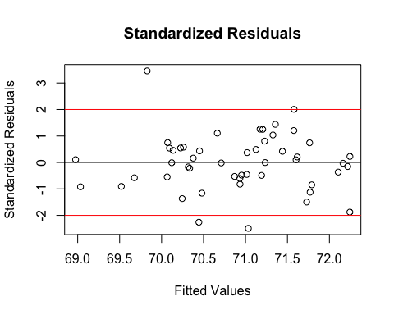

Yes there is a noticeable change in the Standardised residuals. The fitted line has changed. NEW: -

LIFE = 69.8207566 + 0.0922054 (MALE2) - 0.4261398 (BIRTH2) - 0.1377833 (DIVO2) - 0.0011637 (BEDS2) + 0.3157699 (EDUC2) - 0.0004698 (INCO2)

OLD: -

LIFE = 70.5577813 + 0.1261019 (MALE2) - 0.5160558 (BIRTH2) - 0.1965375 (DIVO2) - 0.0033392 (BEDS2) + 0.2368223 (EDUC2) - 0.0003612 (INCO2)

Also, $R^{2}$ s changed: New: Multiple R-squared: 0.3679 Old: Multiple R-squared: 0.4685

3f)

#MALE  
plot(MALE2, std_res_NoDC, ylab="Standardized Residuals", xlab="MALE", main="Standardized Residuals")  
abline(0, 0)  
abline(2, 0, col=c("red"))  
abline(-2, 0, col=c("red"))  
points(MALE[44], std_res_NoDC[44] , col='red', pch = 19)

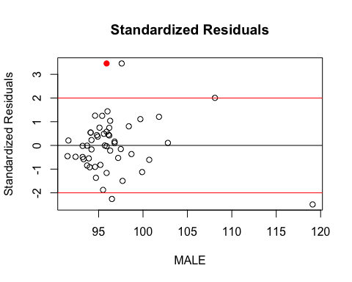

#BEDS  
plot(BIRTH2, std_res_NoDC, ylab="Standardized Residuals", xlab="BIRTH", main="Standardized Residuals")  
abline(0, 0)  
abline(2, 0, col=c("red"))  
abline(-2, 0, col=c("red"))  
points(BIRTH2[44], std_res_NoDC[44] , col='red', pch = 19)

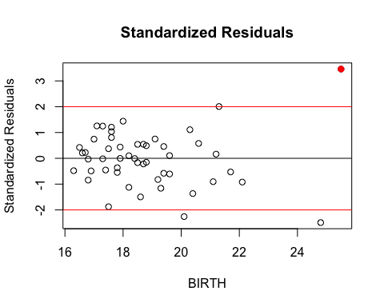

#DIVO  
plot(DIVO2, std_res_NoDC, ylab="Standardized Residuals", xlab="DIVO", main="Standardized Residuals")  
abline(0, 0)  
abline(2, 0, col=c("red"))  
abline(-2, 0, col=c("red"))  
points(DIVO[44], std_res_NoDC[44] , col='red', pch = 19)

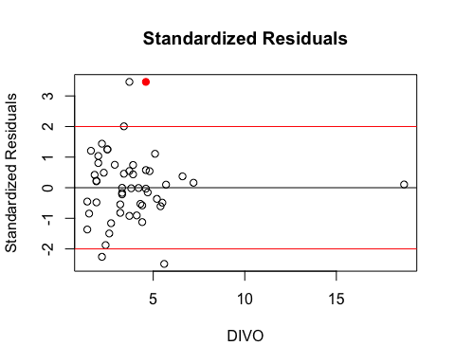

#BEDS  
plot(BEDS2, std_res_NoDC, ylab="Standardized Residuals", xlab="BEDS", main="Standardized Residuals")  
abline(0, 0)  
abline(2, 0, col=c("red"))  
abline(-2, 0, col=c("red"))  
points(BEDS2[44], std_res_NoDC[44] , col='red', pch = 19)

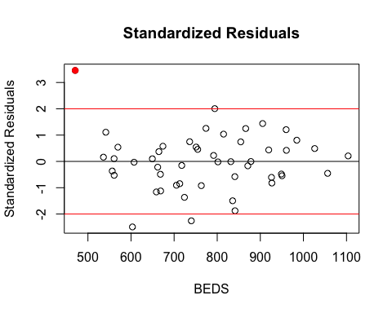

#EDUC  
plot(EDUC2, std_res_NoDC, ylab="Standardized Residuals", xlab="EDUC", main="Standardized Residuals")  
abline(0, 0)  
abline(2, 0, col=c("red"))  
abline(-2, 0, col=c("red"))  
points(EDUC2[44], std_res_NoDC[44] , col='red', pch = 19)

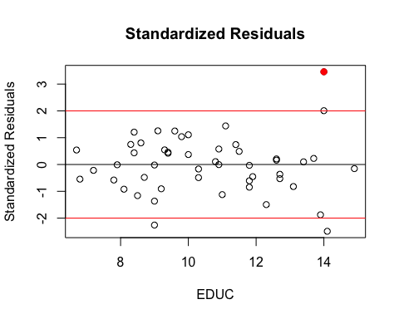

#INCO  
plot(INCO2, std_res_NoDC, ylab="Standardized Residuals", xlab="INCO", main="Standardized Residuals")  
abline(0, 0)  
abline(2, 0, col=c("red"))  
abline(-2, 0, col=c("red"))  
points(INCO2[44], std_res_NoDC[44] , col='red', pch = 19)

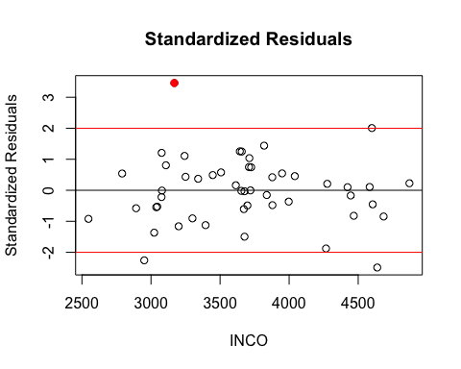 ALL Data corresponding to this STATE has very standardized residual values. Difference between observations and expected values is large.

3g)

dat3 <- subset(dat2, STATE != 'UT')  
LIFE3 <- dat3$LIFE  
MALE3 <- dat3$MALE  
BIRTH3 <- dat3$BIRTH  
DIVO3 <- dat3$DIVO  
BEDS3 <- dat3$BEDS  
EDUC3 <- dat3$EDUC  
INCO3 <- dat3$INCO  
MLR_NoDC_NoUT <- lm(formula = LIFE3 ~ MALE3+ BIRTH3 + DIVO3 + BEDS3 + EDUC3 + INCO3, data=dat3)

$R^{2}$ is higher without UT data. Therefore this model explains the proportion of variability explained by the regression, better.

Predictor have coefficients changed:

MLR_NoDC_NoUT$coefficients

## (Intercept) MALE3 BIRTH3 DIVO3 BEDS3   
## 68.2344178920 0.1494306784 -0.6334939159 -0.1116666651 -0.0007407427   
## EDUC3 INCO3   
## 0.2163469795 -0.0003390279

Vs

MLR$coefficients

## (Intercept) MALE BIRTH DIVO BEDS   
## 70.5577812704 0.1261018758 -0.5160557876 -0.1965375074 -0.0033392036   
## EDUC INCO   
## 0.2368222541 -0.0003612011